

**SE Project Milestone 2**

Bilal Ali (21K-3153)

Abdur Rehman (21K-4529)

Ehaab Tariq Ahmed (21K-3372)

**1. Introduction**

**1.1 Motivation**

The project aims to address the inefficiencies in managing medical quotations by providing a customizable software solution. By automating the process of reading and analyzing medical quotation files, the software will streamline operations for healthcare providers and insurance companies, leading to improved efficiency and cost-effectiveness.

**1.2 Stakeholders**

* Primary Stakeholder: The primary stakeholder is our teacher, Dr. Farrukh Hasan Syed, who will provide guidance and feedback throughout the project. Requirement elicitation will be done through regular meetings and presentations where the teacher can provide input on project goals, features, and priorities.
* End Users: The users who will interact with our product. These include medical professionals who want a quick way to log or filter different medicine from multiple file formats, or patients who want to organize their list of medicines.
* System Administrators: The developers of the product responsible for maintenance and support.
* Regulatory Bodies: These stakeholders may have an interest in ensuring that the software complies with relevant regulations and standards in the healthcare industry.

**1.3 Assumptions and Dependencies**

* Assumptions: It is assumed that the medical quotation files follow a standardized format that can be parsed accurately. Additionally, it is assumed that the stakeholders will provide timely feedback during the development process.
* Dependencies: The project depends on access to medical quotation files for testing and development purposes. Additionally, the availability of development tools and libraries may impact project timelines.

**2. Functional Requirements**

**2.1 HTML Doc Parsing**

The software should be able to parse HTML documents of various structures and extract relevant information, including medication names, manufacturers, and prices.

**2.2 PDF / TXT etc Doc parsing**

The software should be able to parse various file formats (PDF, TXT) of various structures and extract relevant information, including medication names, manufacturers, and prices.

**2.3 Data Accuracy**

Extracted data should be accurate and consistent across different document formats to ensure reliable results.

**2.4 User interaction**

Users should be able to upload their own documents and get the Excel files containing details of various medicines in that document.

**2.5 User Feedback**

Include a mechanism for users to provide feedback on the accuracy of data extraction and suggest improvements for handling various HTML document structures.

**3. Non-Functional Requirements**

**3.1 Performance**

1. Response Time: The system should respond to user interactions within 2 seconds.
2. Throughput: The software should be capable of processing a minimum of 100 medical quotation files per hour.

**3.2 Reliability**

1. Availability: The system should have at least 99.9% uptime.
2. Fault Tolerance: The software should gracefully handle unexpected errors and provide appropriate error messages to users.

**3.3 Security**

1. Authentication: Users should be required to log in with valid credentials before accessing the software.
2. Authorization: Access to sensitive features or data should be restricted based on user roles.

**3.4 Usability**

1. Accessibility: The software should comply with accessibility standards to ensure usability for users with disabilities.
2. User Interface Design: The user interface should be intuitive and easy to navigate, following established design principles.

**4. Constraints**

1. Technical Limitations: Parsing huge numbers of documents (in the thousands) would require investment in paid servers.
2. Budget Constraints: The amount of money given to us for this project might not be sufficient to afford high class equipment, and can restrict how much we built
3. Time Constraints: The time constraint can hinder the project from meeting its full potential, affecting scope of features.

**5. Architecture Design**

**5.1 Overview**

The system will follow a pipe and filter architecture,, with a web-based frontend for user interactions and a backend server for data processing and storage.

Users will be able to upload documents of various file formats (HTML, PDF, CSV) and a downloadable Excel file will be generated with relevant details

**5.2 Component Diagram**

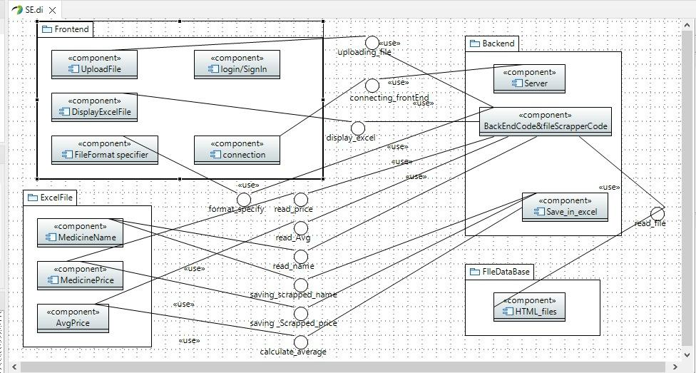

**5.3 Deployment Diagram**

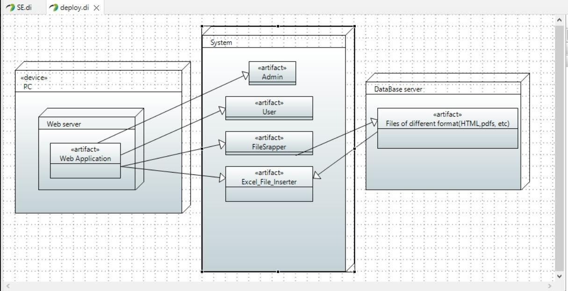

**6. Revision History**

**4th April 2024 11:47 PM: First draft.**